NAME: G. Yashmita REG NO: 192511032
(JIRA)
EXPERIMENT 12: MOSCOW
You are designing a Task Management System for a small team. The
system should include the following features:
1. User Login and Role Assignment
2. Task Creation and Assignment
3. Task Prioritization and Deadlines
4. Progress Tracking and Reporting
Prioritize these requirements using the MoSCoW in
Jira.

Aim

The objective of this experiment is to design a Task Management System for a small team and prioritize its requirements using the MoSCoW and Kano models in Jira Software.

Software Requirements

Software: Jira Cloud (Web Application)
Web Browser: Google Chrome / Microsoft Edge
Internet Connection: Required

Theory
Requirement prioritization is an important activity in software engineering that helps development teams focus on implementing the most valuable features first. The MoSCoW model categorizes requirements into Must Have, Should Have, Could Have, and Won't Have based on their priority. The Kano model classifies requirements based on customer satisfaction into Basic (Must-be), Performance, and Delighter (Excitement) features. Using these models in Jira helps teams plan projects efficiently, manage resources, and deliver high-quality software.

Procedure

Step 1:

Open a web browser, log in to Jira Software, and create a new project for the Task Management System.
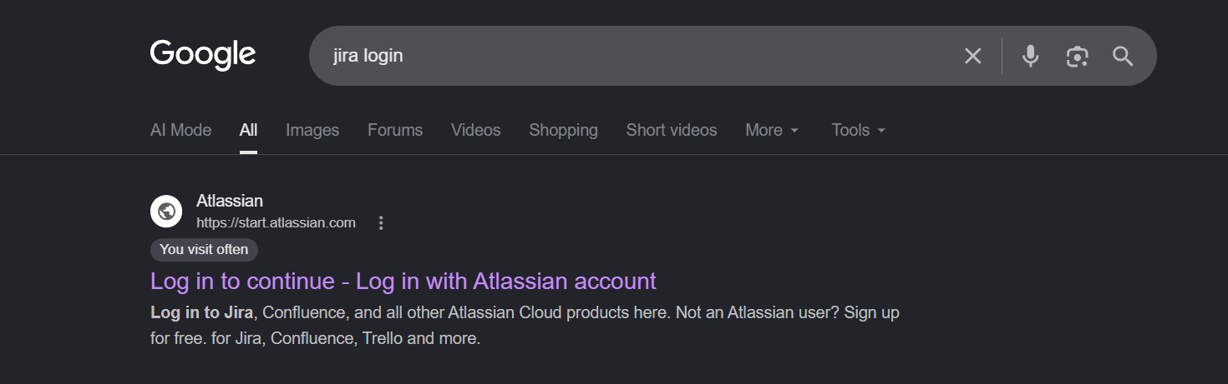
Figure 1. Creating a New Jira Project.

Step 2:
Create the following four Jira issues:
- User Login and Role Assignment
- Task Creation and Assignment
- Task Prioritization and Deadlines
- Progress Tracking and Reporting
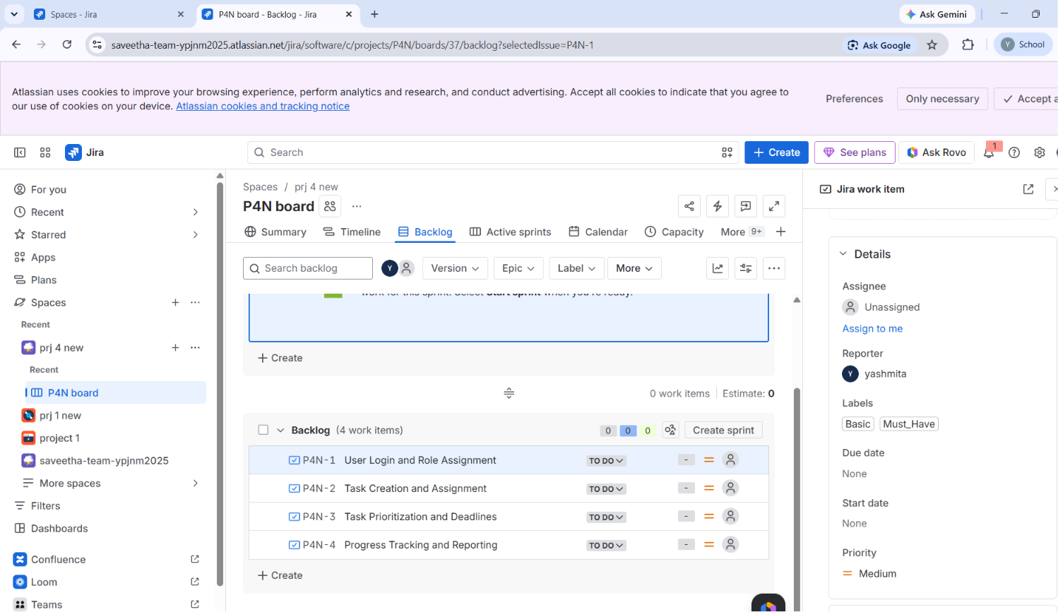
Figure 2. Creating Jira Issues.

Step 3:
Apply the MoSCoW prioritization model by assigning the following categories:
- Must Have: User Login and Role Assignment
- Must Have: Task Creation and Assignment
- Should Have: Task Prioritization and Deadlines
- Could Have: Progress Tracking and Reporting
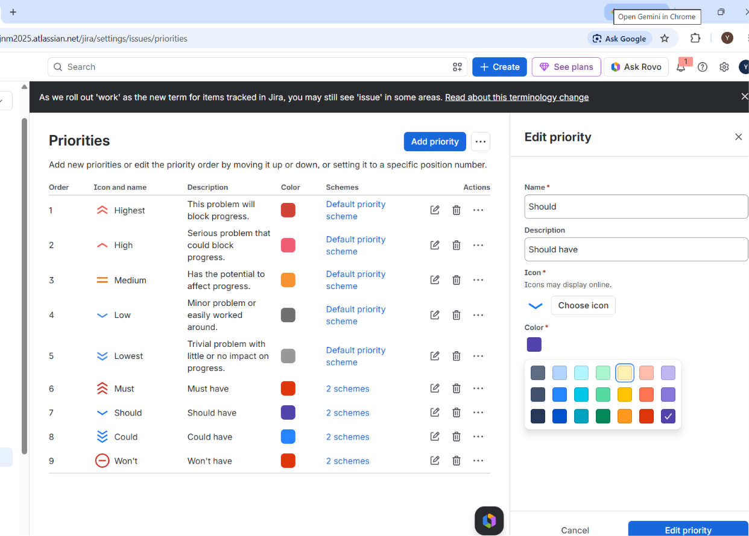

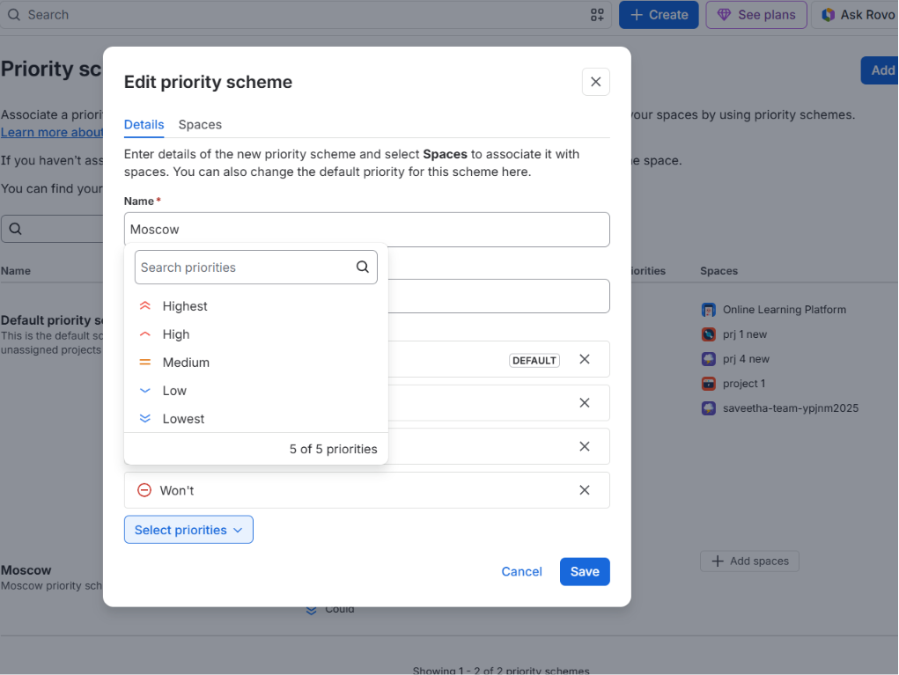


Step 4:
Open the Kanban Board or Backlog to verify that all Jira issues display their assigned MoSCoW priorities and Kano classifications. Save the changes.
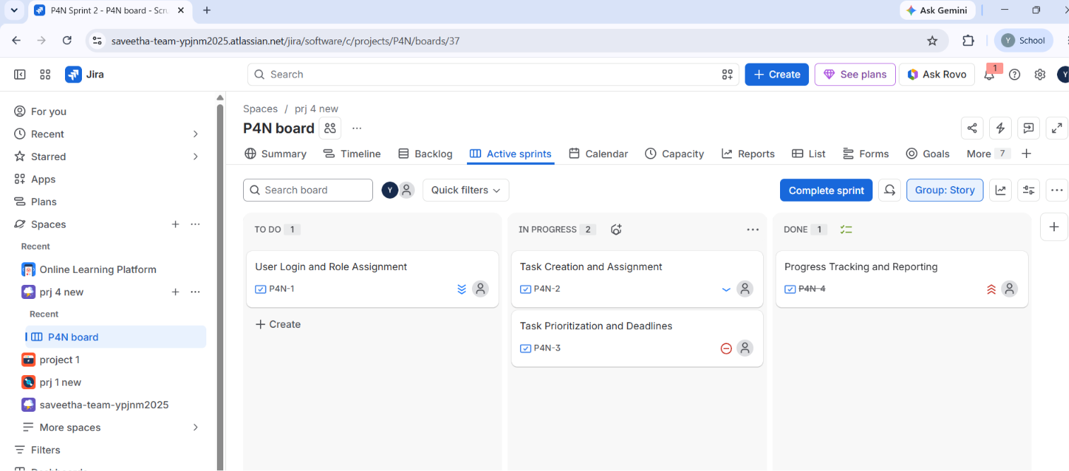
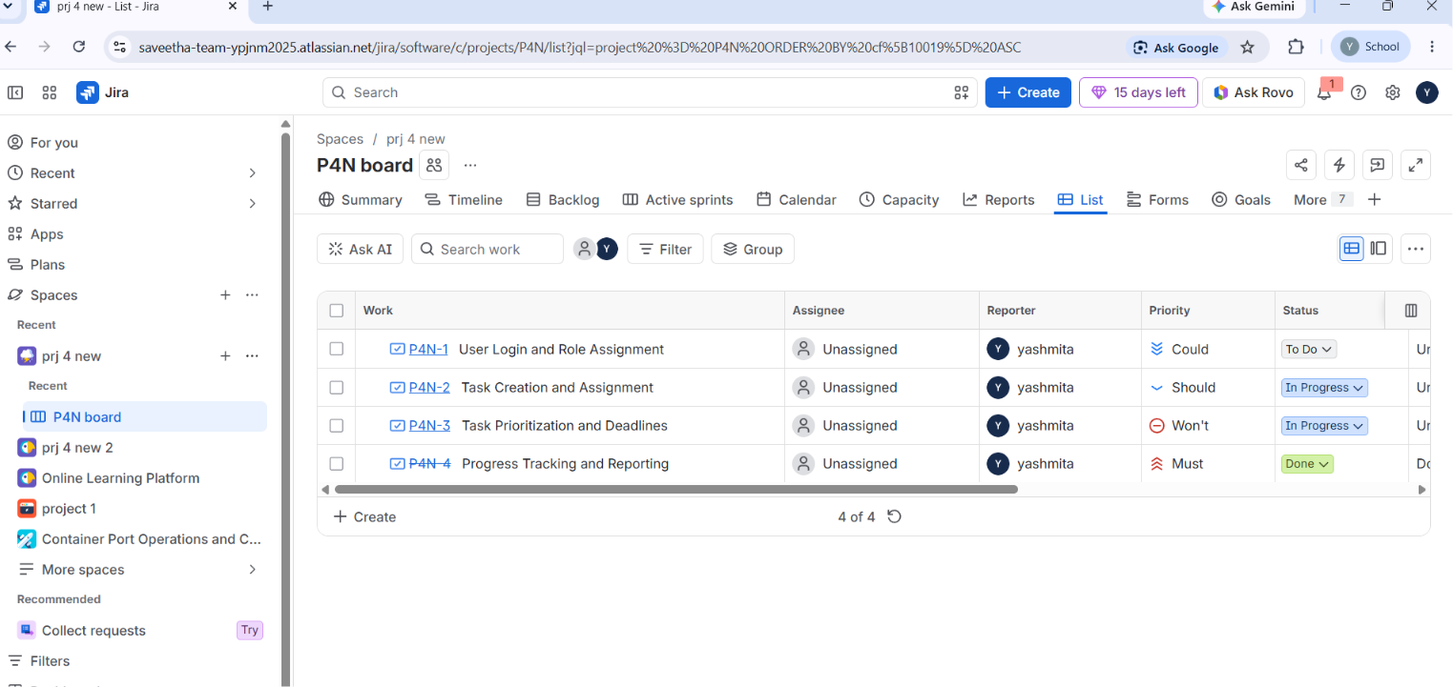
Figure 4. Verifying Requirement Classifications.

Result

The requirements of the Task Management System were successfully prioritized using the MoSCoW and Kano models in Jira Software. The experiment demonstrated how requirement prioritization helps development teams identify essential features, improve planning, allocate resources effectively, and enhance customer satisfaction during software development.

